Leading the way to the pinnacle

Climbing Mount Everest takes skill, plans, a strong team and luck. But it’s how people work together that matters most – just as it does in business

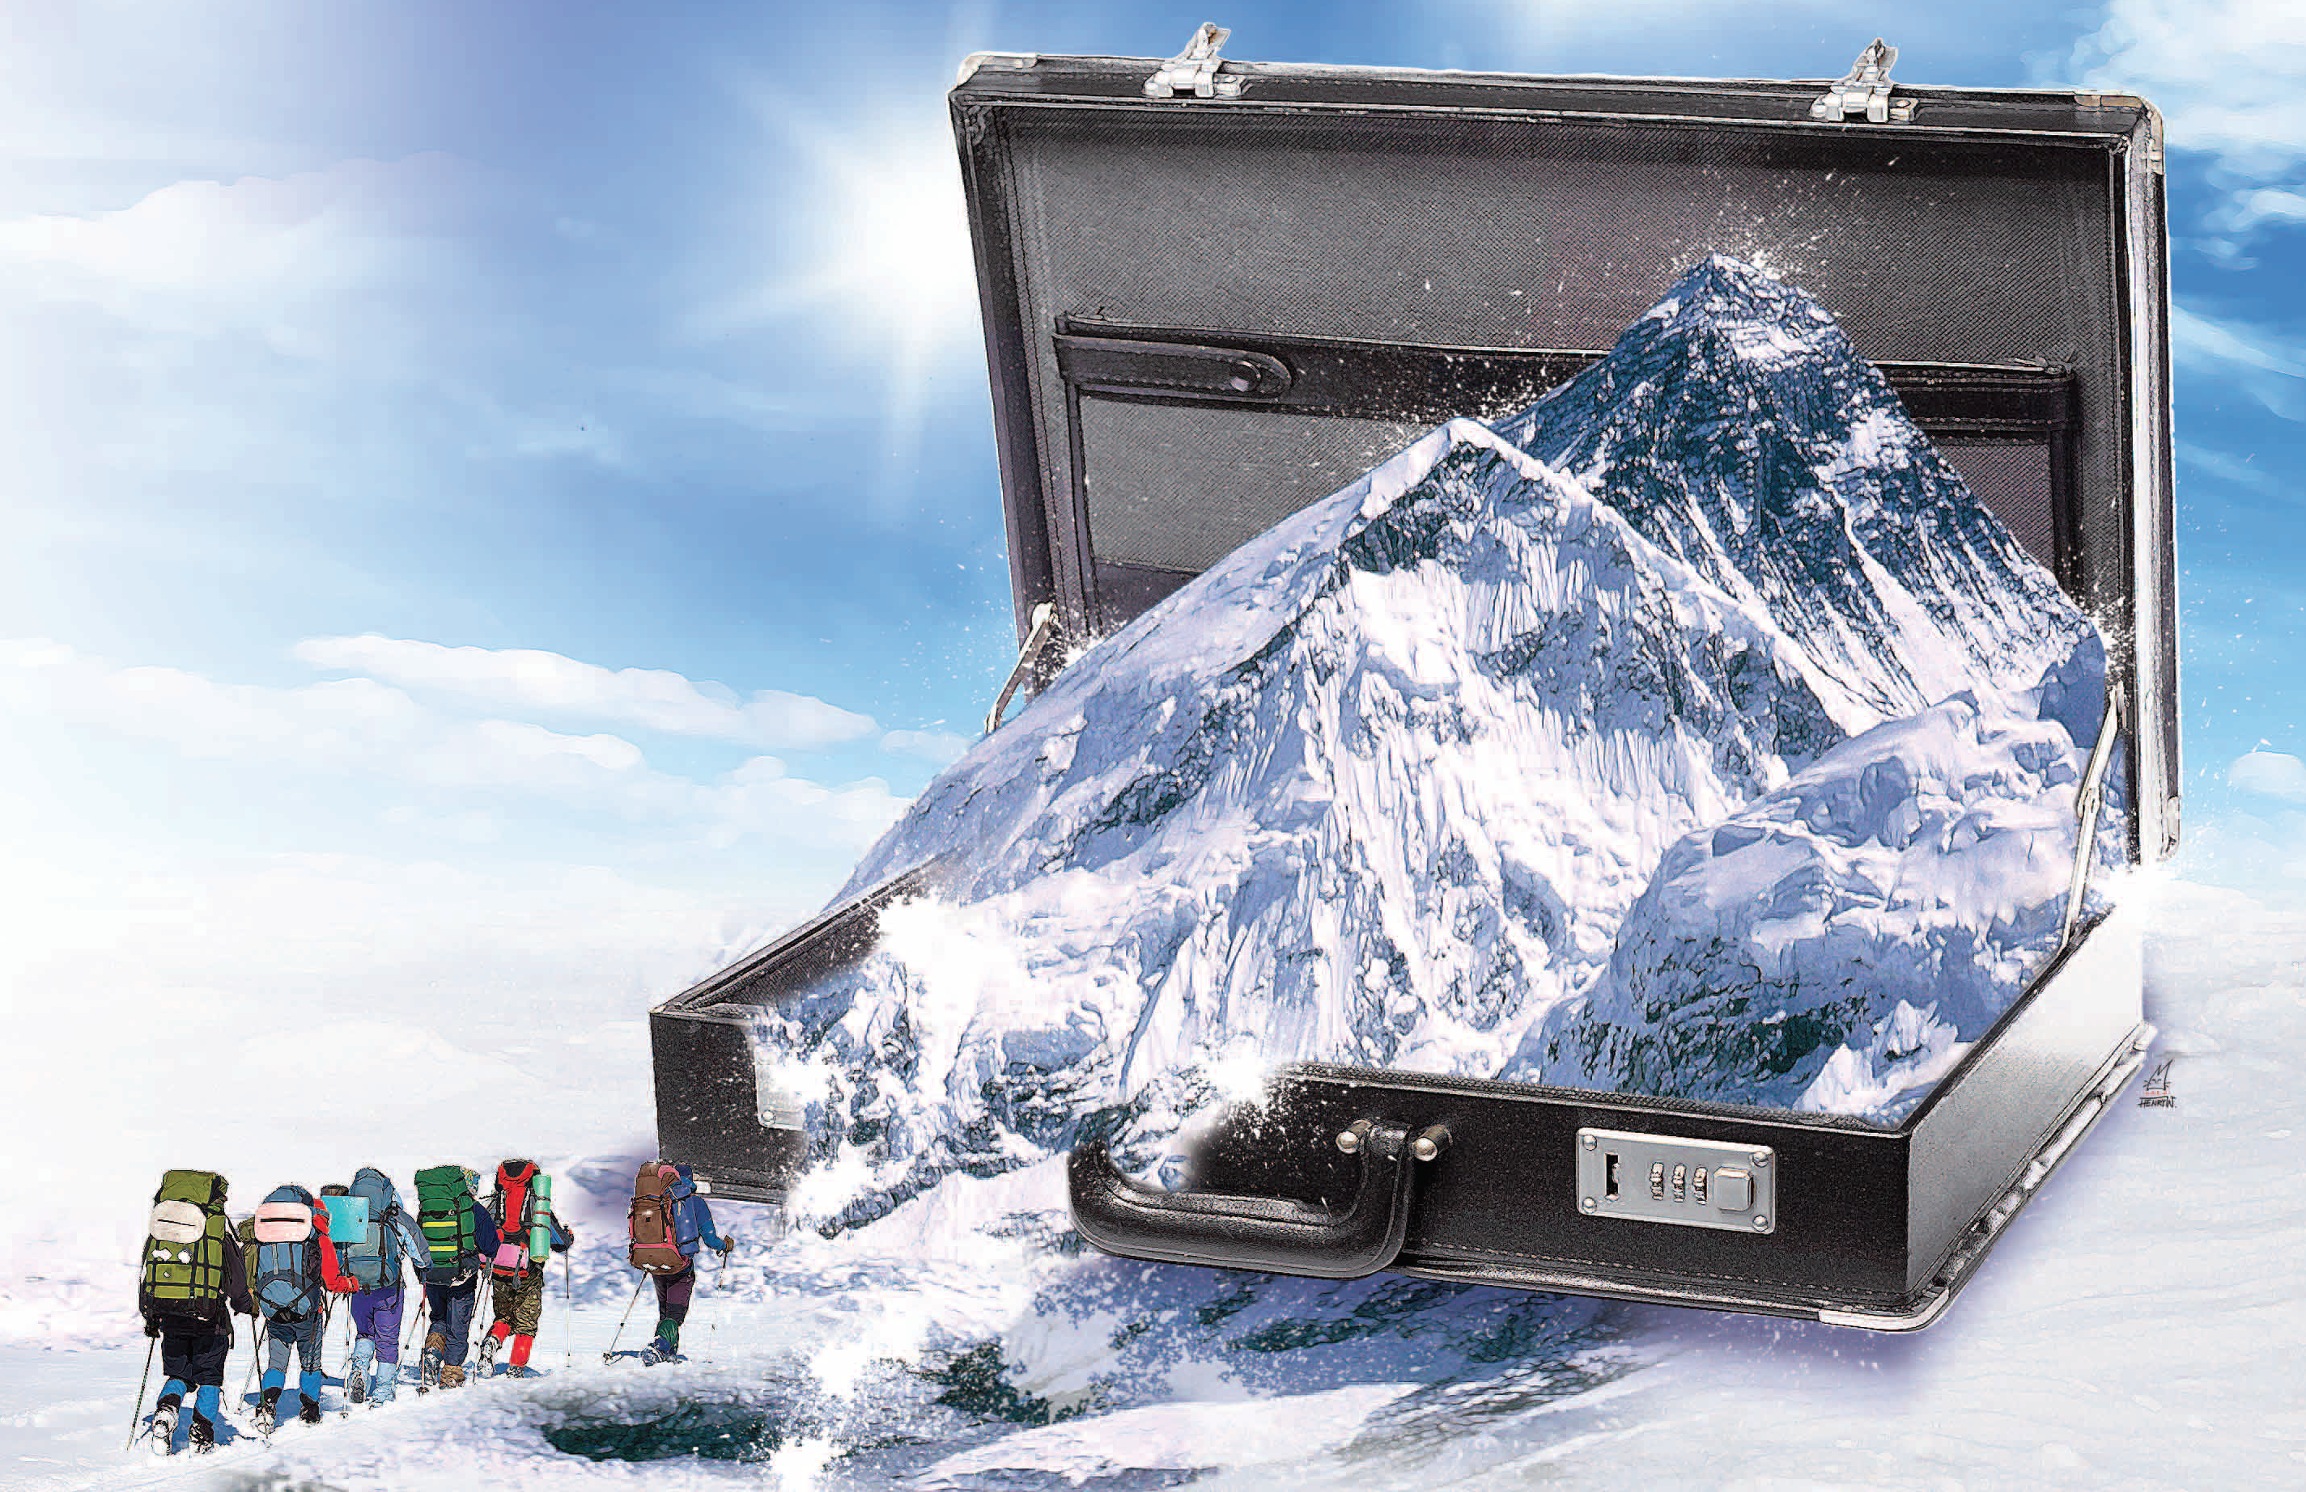 ILLUSTRATION: HENRY WONG

By Randel S. Carlock, INSEAD

Mount Everest was in the headlines again this spring when ten climbers died, including a Chinese national Wang-yi Fa, triggering memories of 1996, the deadliest year on Everest. On May 10, 1996 there were several different expeditions making summit bids for Everest, when a freak storm struck in the late afternoon and pounded the mountain. The cold temperatures and unrelenting winds hit the area known as the “death zone” from Camp IV to the Hillary Step, preventing climbers from getting down and rescuers from getting up.
Two guided climbing groups with paying clients, Mountain Madness and Adventure Consultants, were caught on the mountain and five people died. The dead included Rob Hall, the safety-conscious leader of the Adventure Consultants team, and Scott Fischer, the charismatic leader of the Mountain Madness team. Also on the mountain that day was an experienced team of mountaineers who were making an IMAX movie. David Breashears and his co-leaders had decided that an ascent would be too risky, so they had retreated with their filming equipment to the lower altitudes of Camp II to wait out the weather.
As any experienced mountaineer will tell you, ascending Mount Everest demands skill, planning, a strong team and some luck. Technical skills like climbing expertise and planning for the right amount of oxygen can all be measured against the experience of other climbers who have succeed or failed in their attempts to conquer Everest. Unfortunately, the most important and difficult factor to measure is the human skills needed for building and leading a team that can meet the challenges of each climbing situation. Business teams face the same challenge. Despite having the right technical skills and sound plans, successful performance is often dependent on the human dimension of how the team works together to overcome the bad luck of unforeseen challenges or to exploit the good luck presented by new opportunities.
The story of the three 1996 climbing teams has been well documented in newspaper and magazine articles and books, including Into Thin Air and The Climb: Tragic Ambitions on Everest, and films such as Breashears’ IMAX Everest and Storm Over Everest. There are even two business school case studies, Harvard Business School’s, Mount Everest—1996 and INSEAD’s Tragedy on Everest. All of these document that the three leaders displayed professionalism in their technical preparation but differed in how their teams were organized and led – a difference that became significant advantage for the IMAX team when the life-threatening storm hit the mountain.
A helpful model for comparing and contrasting differences in leadership of teams is GRPI: Goals, Roles, Process and Interpersonal. Many companies, including General Electric, use it to standardize team leadership and performance. GRPI teaches us that, while the technical side of management is important, the real differentiator is how leaders shape and direct the team’s social interactions, especially in complex and high-stakes situations.
The GRPI model can improve team efficiency and efficacy by enabling leaders and team members to focus first on the critical actions for strengthening their team instead of rushing into the team’s stated task (and possibly failing). Planning, that is actively setting goals and agreeing on roles, is more effective than using a trial-and-error method, followed by diagnoses and problem solving. So what can the Everest story tell us about developing and leading more effective business teams? The answer to this question lies in using the first two elements of GRPI, goals and roles, to compare and contrast the various 1996 teams.
Research into teams demonstrates that 80 to 90% of team conflicts are the result of unclear goals or roles, so ensuring that the team shares a goal and has full agreement on roles is a powerful first step to improving performance. And initially, it would appear that the three 1996 teams had the identical goal of climbing Mount Everest. But a deeper analysis shows significant differences. First, the IMAX team had a larger goal than climbing Everest; they were making a film about climbing Everest that would let millions of people around the world into the experience of mountaineering. There was also a significant difference in how the individual team members viewed their goals. The IMAX team had a shared goal (making the film) that demanded shared success, while the guided teams had a common goal (climbing Everest) based on individual accomplishment.
John Krakauer, one of the Adventure Consultants team members, in his book Into Thin Air, captures the importance of shared goals. He writes: “We were a team in name only, I'd sadly come to realize. Although in a few hours we would leave camp as a group, we would ascend as individuals, linked to one another by neither rope nor any deep sense of loyalty. Each client was in it for himself or herself, pretty much. And I was no different: I sincerely hoped Doug got to the top, for instance, yet I would do everything in my power to keep pushing on if he turned around.”
If goals are the team’s targets then roles provide the structures to steer the team’s efforts toward accomplishing their goals. Team leadership is a combination of directive and supportive behavior – the amount of freedom of action that the leader chooses to allow a team versus the level of authority that the leader maintains. The 1996 Everest disaster presented us with three different styles of team leadership. Rob Hall of Adventure Consultants was definitely the controlling leader. His favorite saying was, “My word is the law on the mountain.” Scott Fischer took a more laissez-faire approach and often ended up taking care of problems himself rather than delegating. David Breashears structured the IMAX team based on expertise – with responsibility and participatory decision-making within a trusted senior group.
Roles reflect the leader’s style and create a clear understanding of who is doing what, who is responsible for what and what the limits of their authority are. When team members have a clear understanding of roles, it makes the team more effective. Rob Hall saw his role as the boss who assumed full control of his team’s actions. Scott Fischer saw himself as an expert role model for others to follow. And again the IMAX team stands out. Because of the complexity of the project, David Breashears shared leadership with Ed Viesturs, who focused on the climbing so that he could focus on the filmmaking. After all, the challenges posed by the IMAX equipment were considerable. In effect it gave the team “five extra climbers” who had to be carried to the top of Everest.
So what does the Mount Everest case teach Asian bosses concerned about improving the effectiveness of their teams and organizations? The obvious answer is that complex or innovative projects, such as an international joint venture or climbing Mount Everest, require an empowered team lead by a “supporter” rather than “a boss”. The team leader must appreciate that you need to build and support the team to accomplish your business goals. I have developed a short questionnaire to help team leaders assess their teams and themselves to develop a better understanding of the team’s strengths and weaknesses to improve the team’s functioning (See Figure One on the last page).
Asian business executives must recognize that the most important lesson from the events on Mount Everest of 1996 is that the leader should balance a natural concern for climbing the mountain with the equally important team building tasks of setting goals, clarifying roles, developing team processes and monitoring interpersonal relationships. There are many different ways to lead a team successfully, provided we understand the fundamental factors for success, that is the linkages between goals and roles that engage individuals, teams, organizations – and even expeditions to the highest point on the planet.

Figure One
GRPI: assessing your team Your Team
Low High
Goals
1. The shared goal is clear and individuals are committed 1 2 3 4

Roles
2. The work is organised in a way that clearly leads to achieving the team’s goal 1 2 3 4
3. Everyone is clear about his/her responsibilities and the job he/she has to do 1 2 3 4
4. There is balanced use of the different leadership talents 1 2 3 4

Processes
5. Decisions are timely and effective 1 2 3 4
6. Conflict on the team is addressed openly and constructively 1 2 3 4
7. The leader monitors team performance and makes adjustments to
ensure team and individual effectiveness 1 2 3 4

Interpersonal
8. There is trust in communication and relationships 1 2 3 4
9. Flexibility and creativity are encouraged 1 2 3 4
10. Capabilities are developed and used 1 2 3 4

Total score for your team

Randel Carlock is Berghmans Lhoist chaired professor in entrepreneurial leadership at INSEAD business school, which has campuses in France, Singapore and Abu Dhabi.

